# CS 255 System Design Document Template

Shatoria Giles

## UML Diagrams

### UML Use Case Diagram

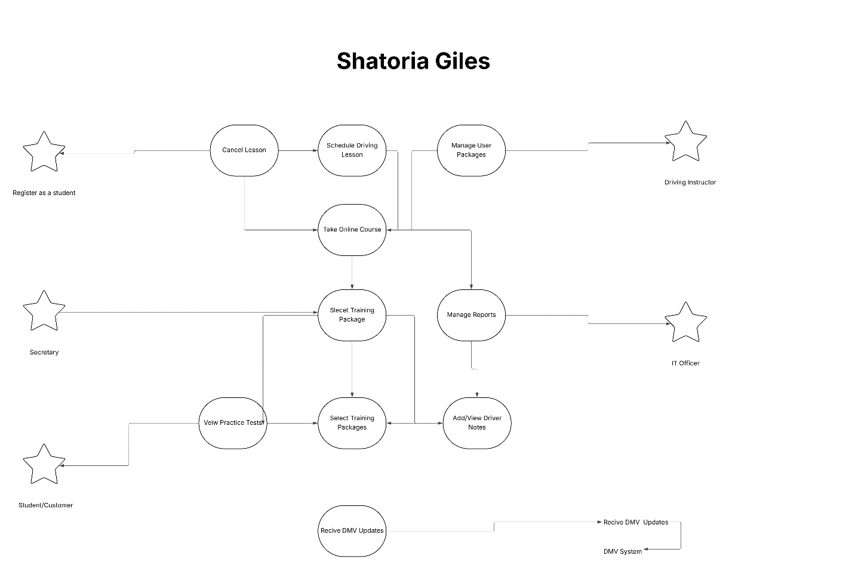

### UML Activity Diagrams

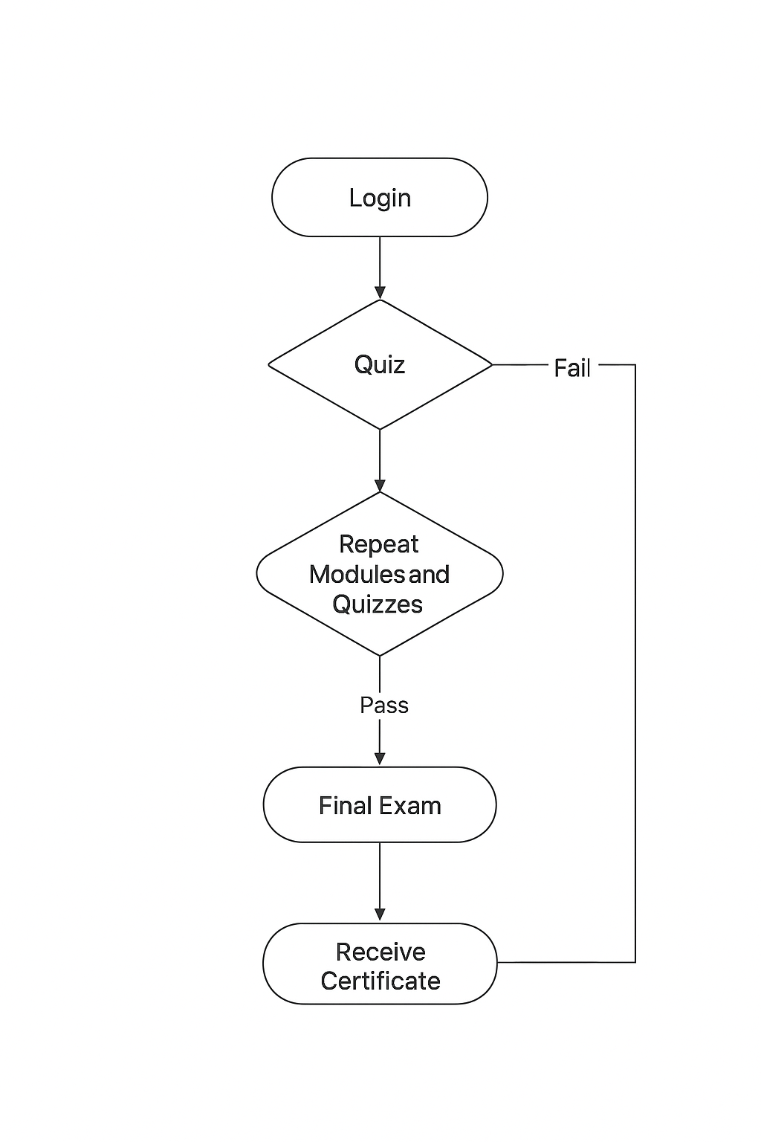

### 

### UML Sequence Diagram

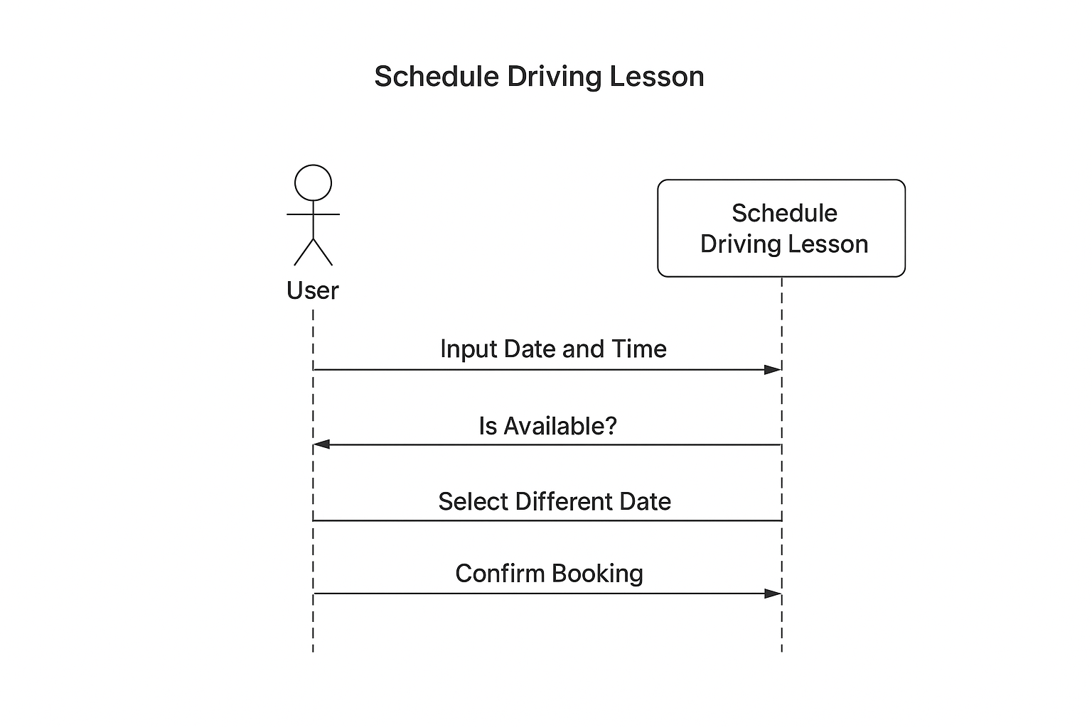

### UML Class Diagram

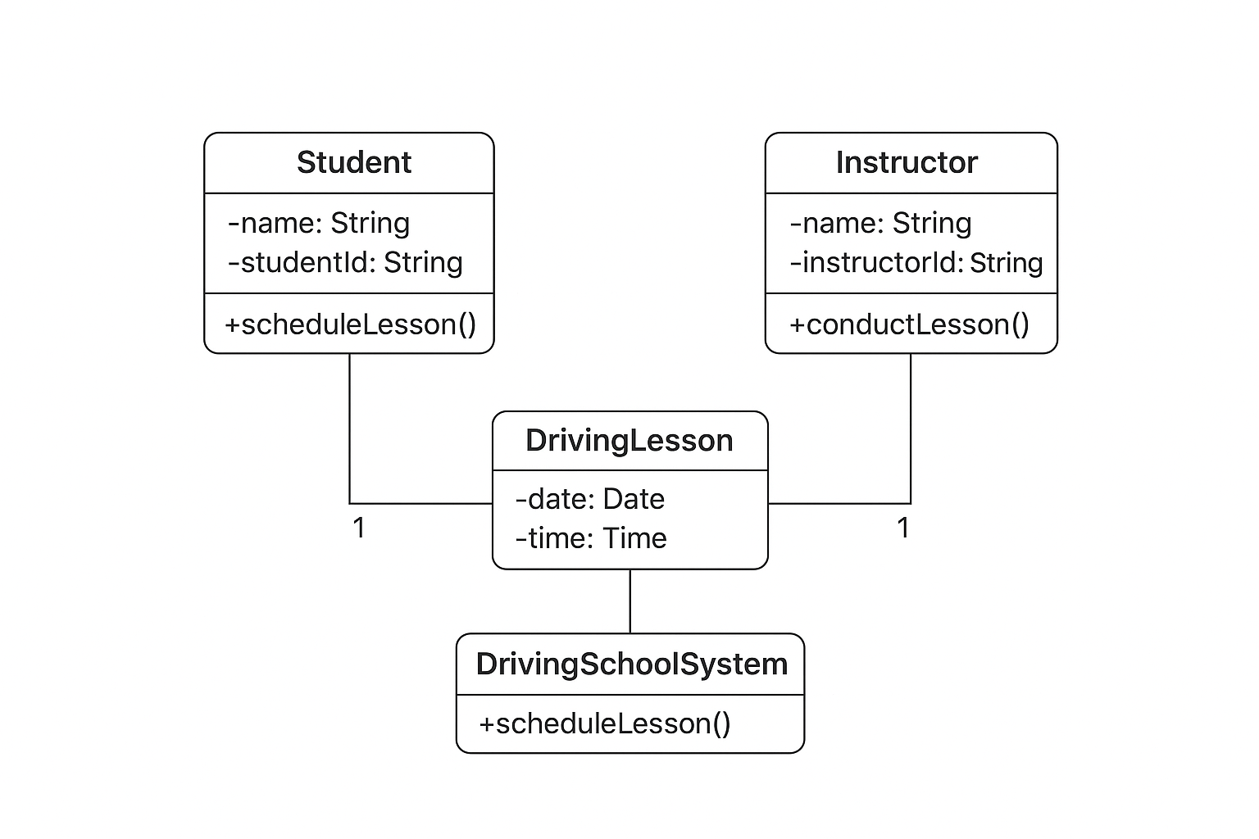

## Technical Requirements

*The system requires a computer or mobile device with internet access, a web browser, and a stable network connection. It uses a web-based platform built with Java, HTML, and SQL for data storage. The server runs on a cloud-based environment to host user accounts, manage driving lessons, and store reports. Lucidchart or similar CASE tools are used for design and documentation.*